**Business Question and Visualization Report**

| Date | 1 August 2025 |
| --- | --- |
| Team ID | xxxxxx |
| Project Name | Exploring Global Energy Generation |
| Maximum Marks | 5 Marks |

**Executive Summary**

This report presents data analysis of global energy trends from 1990 to 2020. The visualizations were developed to provide a clear and intuitive understanding of complex datasets, enabling us to identify key insights into renewable and non-renewable energy production, as well as consumption patterns across different countries and continents. The goal is to inform strategic decisions regarding energy policies and investments by presenting a clear picture of historical trends and current contributions from various energy sources.

**Questions and Visualisation**

The process involves defining specific business questions to guide the creation of meaningful and actionable visualizations in Power BI. Well structured questions help in identifying key metrics, selecting relevant data, and building visualization that provide insights.

1. Which country is the largest contributor to renewable energy generation among the top 20 shown in the pie chart?

Answer:

Based on the size of the slices in the “Top 20 Country by Renewable Energy” pie chart, China is the largest contributor, followed by the USA and Brazil.

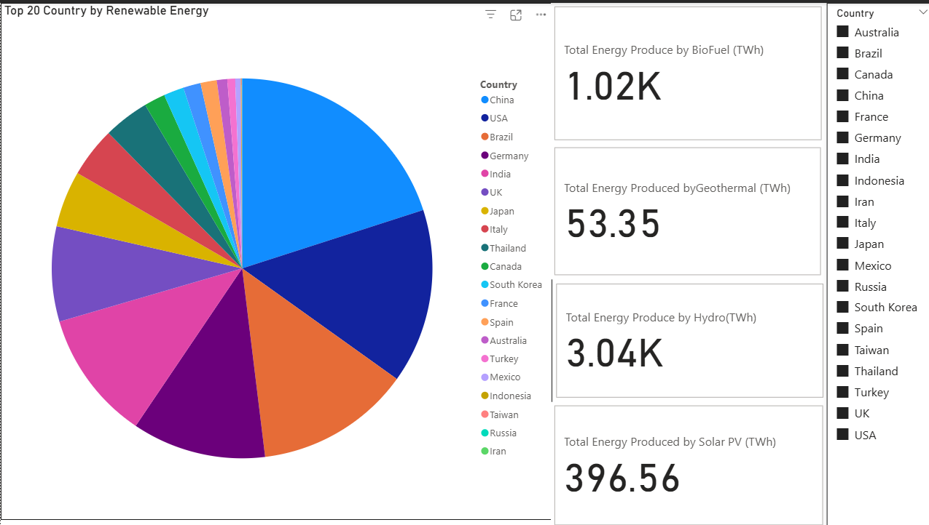

1. What is the primary source of non-renewable energy generation, and what is its contribution percentage?

Answer:

According to the “Sum of Contribution (TWh) by Mode of Generation” pie chart for non-renewable sources, Coal is the primary source, contribution 50.72% of the total.

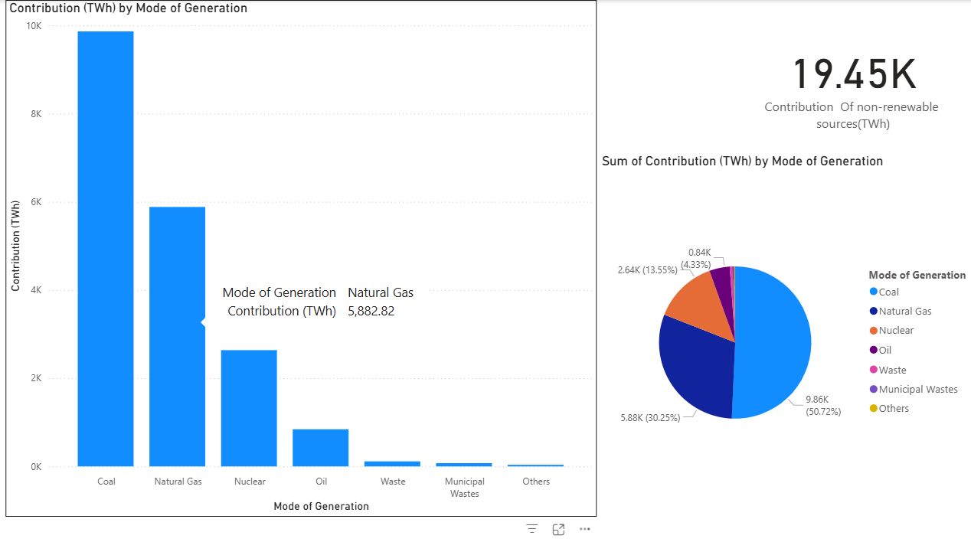

1. How does the contribution of Natural Gas compare to Coal in non-renewable energy generation?

Answer:

The “SUm of Contribution (TWh) by Mode of Generation” bar chart and pie chart for non-renewable sources show that Coal’s contribution (50.72%) is significantly higher than that of Natural Gas (30.25%).

1. What is that total contribution of the non-renewable sources in TWh?

Answer:

THe card in the “Contribution (TWh) by Mode of Generation” state that “19.45K Contribution of non-renewable sources (TWh)”.

1. How much power was generated by Hydro and Solar PV combined , according to the summary card?

Answer:

The summary card in the “Power Production By Renewable Sources” it shows that Hydro produced 83.28K TWh and Solar PV produced 1.61K TWh. The combined total is 83.28K + 1.61K = 84.89K TWh.

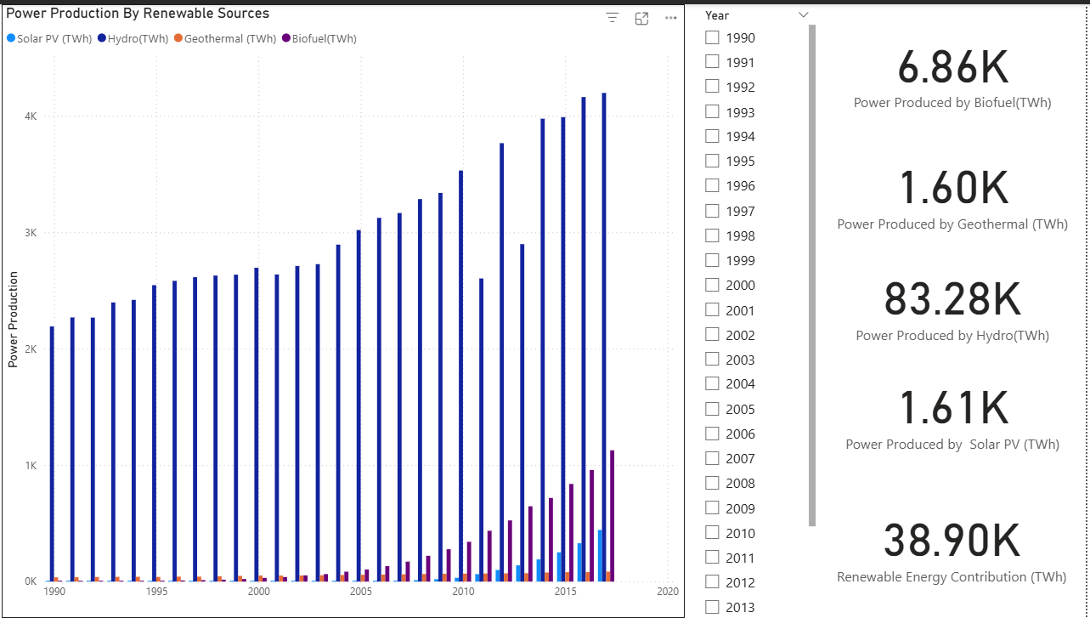

1. What was the total renewable energy contribution in TWh as a whole, according to the dashboard?

Answer:

The card titled “Renewable Energy Contribution (TWh)” shows the value **38.90K**

1. Which renewable energy source shows the most significant growth in power production from 2010 to 2017, and which one remain the most dominant?

Answer:

Looking at the “Power Production By Renewable Sources” bar chart, Solar PV (represented in light blue) shows a dramatic increase in power production starting around 2010. However, Hydro (represented in dark blue) remains the most dominant source throughout the period.

1. What is the second-largest contributor to renewable energy generation, based on the pie chart for the mode of generation?

Answer:

The “Contribution (TWh) by Renewable Source Generation” pie chart shows that after Tidal, which is the largest slice, Hydro is the second largest contributor to renewable energy generation.

1. Between 1990 and 2020, which continent's or economic group consistently had the highest energy consumption ?

Answer:

The “Energy Consumption By Continent” bar chart shows that North America consistently had the highest energy consumption throughout the period from 1990 to 2020.

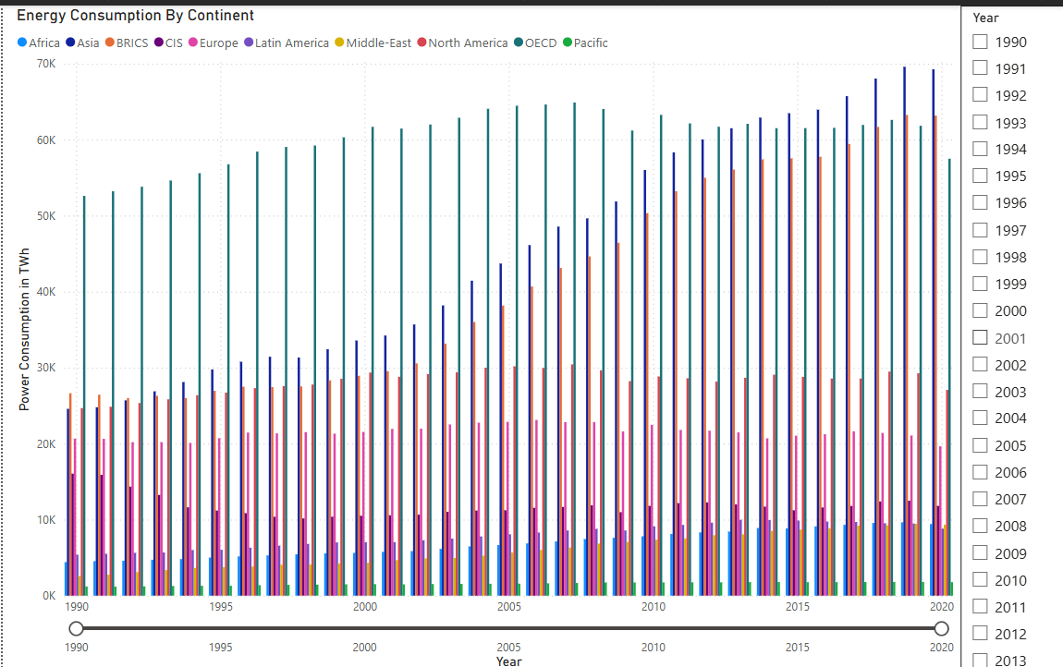

1. Which two countries have the highest energy consumption, as depicted in the “Energy Consumption by Country Over Years” chart?

Answer:

The bar chart titled “Energy Consumption by Country Over Years” clearly shows that **China** slightly surpassed the **United States** in later years.

